

Cricket Education in Herefordshire 2026

Coach Development
Foundation Coach Course – Level 1
Next course Sunday 13th April 2026 9.30-4.30pm and Tuesday 15th and Thursday 17th 6.00-9.00pm.
BOOK HERE
Who is it for?
Anyone aged 17 and over wishing to become qualified to coach cricket, inspire players and make a difference to the game.
This programme has been designed to give learners the knowledge, skills and confidence to coach cricket sessions that are purposeful, active, safe and enjoyable.
An ECB Foundation Coach will be qualified to lead coaching sessions independently and without supervision.

What commitment does the programme require?
• £150.00 (Bursaries are available) click here for more information on BURSARIES
LOCAL COACHES CONTACT THE OFFICE FOR A 25% DISC supported by HCL. Kirsty Sockett
- 4 face-to-face modules lasting 3 hours each, including 2 observed
- Coaching opportunities & 7 bitesize e-learning modules lasting 15-20 minutes each
- Multiple choice question assessment

Content
• Role of an ECB Foundation Coach
• icoachcricket
• What does coaching look like?
• Coaching fielding, bowling and batting
• Foundation principles – fielding, bowling and batting
• The coaching tools, Differentiation & Safety

What are the prerequisites for certification?
• 17 years of age (Certificate will arrive once attendee is 18)
• Valid ECB DBS
• Valid safeguarding training

What learning opportunities can be accessed after the programme?
Full membership of the ECB Coaches Association and ECB Core Coach.
Certificate - Issued by 1st4Sport

Core Coach - Level 2
Next course Sunday 1st February 2026, Sunday 8th February , Sunday 15th February, Sunday 22nd February 2026 9.30am-4.30pm Halo Bridge St Sports Centre, Leominster.
Book Here
Who is it for?
Anyone aged 17 and over wishing to become qualified to coach cricket, inspire and develop players and make a difference to the game.
Experience of playing or coaching cricket is desirable but not essential when applying for this programme.
This programme has been designed to give learners the knowledge, skills and confidence to lead player-centred coaching sessions.
An ECB Core Coach will be qualified to lead coaching sessions independently and without supervision.

What commitment does the programme require?
• £300.00 (Bursaries are available) click here for information on BURSARIES
LOCAL COACHES CONTACT THE OFFICE FOR A 25% DISC supported by HCL. Kirsty Sockett
- 8 face-to-face modules lasting 3 hours each including 2 observed coaching opportunities & 6 bitesize e-learning modules lasting 15-20 minutes each
- Multiple choice question assessment & Short answer question assessment

Content Includes:
• Player-centred planning process, Player development & Coaching Tools
• Core principles – batting, bowling (pace and spin), fielding and wicketkeeping
• Tactical knowledge, physical fundamentals and mental skills
• Differentiation, Safety, The continuum of practice.
• Role of an ECB Core Coach & icoachcricket

What are the prerequisites for certification?
• 17 years of age (Certificate will arrive once attendee is 18)
• Valid ECB DBS
• Valid safeguarding training

What learning opportunities can be accessed after the programme?
Full membership of the ECB Coaches Association & ECB Advanced Coach.
Certificate - Issued by 1st4Sport.

Activator Training for National Programmes


Minimum age: 18 years of age
Cost FREE of charge.
The Activators that lead our National Programmes, All Stars Cricket and Dynamos Cricket, are vital in igniting a love of cricket and in many cases the first person that a child entering the game will come across. All Stars sessions focus on allowing kids to learn the skills of the game with children in Dynamos sessions developing those skills to apply them in a game setting, In both cases the aim is always to put the child’s development at the fore front of what they do and to create a fun, exciting and engaging environment.
The Initial Activator Training is formed of two elements, Theory and Practical as described below…..
Theory – These modules are elements that underpin the practical delivery of the training programme. The content is outlined in the Activator Training Presentation that is in the Tutor Training Resources of the National Programmes Sharepoint. These elements are designed to be delivered in a classroom/non practical setting (In person or virtually) and CCBs can adapt to the environment and delivery method as required.
Practical – These modules are practical activities delivered in a pitch or sports hall setting face to face. The module descriptors and activities are outlined in this document. Tutors will require sufficient National Programmes equipment to deliver the below activities
Next Course Tuesday 21st April 2026 To register your interest CLICK HERE

Young Cricket Collective - BRAND NEW!!

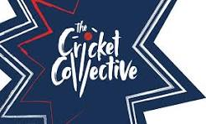

For our Young Volunteers aged 14-18yrs old. The programme involves training on becoming a Young Activator, Young Official, and a Young Club Leader. Once the training has been accessed, participants will go back to their club and use their new found skills and be assessed at the end of the season by their cricket board. Course date tbc. To register your interest CLICK HERE

ECB ACO Introduction to Umpiring Course

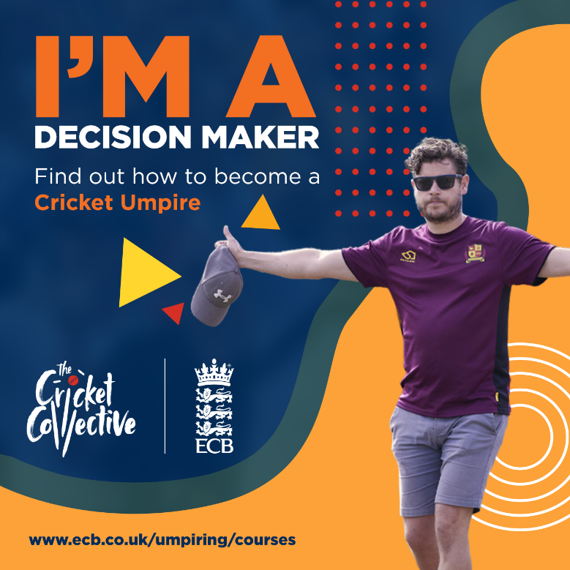

ACO are pleased to announce the launch of a new, FREE online umpiring education module. This is part of our ongoing commitment to supporting the development of officials at all levels of the recreational game and enhance the quality and consistency of officiating.
This offer is aimed at those who are interested to know more about the key laws of the game and how to umpire, without committing to the formal ECB Umpire Course. Completion of this learning does NOT grant access to the ECB Umpire Progression Pathway and completing the full ECB Umpire Course is required to join the pathway.
ACCESS: The module is open and free to all and can be accessed here.
CONTENT: Designed to provide foundational knowledge of the game of cricket, the learning is aimed at those who are new to cricket, umpiring or are a parent/guardian looking to support their child at their club.
DURATION: The module takes approximately 60 minutes to complete.
MINIMUM AGE: Minimum age is 13 years old.
COST: Free of charge
For further information on umpiring courses please contact Roger Welch or Simon King



Safeguarding Training

Introduction to Safeguarding - This FREE course is available for everyone involved in cricket. The training provides basic knowledge and advice in creating a safe cricket environment for everyone, recognising signs of abuse, what to do if you have any concerns or if you are approached by anyone with concerns that they may have.
This training should take around 30 minutes to complete and is accessible on a laptop, tablet or mobile phone. You can access this training by clicking HERE
Please note this course is not certified.
Those who have already undertaken safeguarding training in their roles such as Coaches and Safeguarding Officers are not required to complete this course, although individuals may do so if they wish.

Safeguarding Level 2 - Safeguarding Level 2 is the new course from the Cricket Regulator Safeguarding Team on behalf of the ECB, which has replaced Safeguarding for Specialist Roles (SSR).
Robust safeguarding helps to keep our cricket community safe and welcoming. This course will provide the learner with what to look out for and how to respond to concerns.
The Audience:
- Coaches or Activators
- Officials
- Captains/Vice-Captains
- Team Managers, Junior Supervisors, Volunteer Coordinators
- Chairs and Committee Members
- Club and League Safeguarding Officers
- Describe how to report and record safeguarding concerns
This training should take around 1 hour to complete. The certification is valid for 3 years. You can access this training by clicking HERE.
COST: Free of charge
Please note if you have an active accreditation on a version of SSR courses you do not need to complete this course until your re-accreditation window opens and the course is available in the Active Learning section on your dashboard as your original accreditation data will be retained. To check accreditations, you can find this in the learning history section on your dashboard.

Training for Club Safeguarding Officers
Club Safeguarding Officers are vital members of the club and key to making an environment safe, welcoming and friendly for everyone to enjoy the game of cricket.
Club Safeguarding Officers need to complete two sets of training:
- Safeguarding Level 2 (online)
- Safe Hands workshop - Level 3 (face to face)
These courses should be updated every 3 years.
Club Safeguarding Officers must be over 18 years of age and hold a current ECB issued DBS Certificate.
Next course is Tuesday 24th March 6.00-9.00pm and you can book HERE
Cost is £30


The next first aid course for coaches and volunteers in cricket is TBC :
Cost £30. To register your interest CLICK HERE

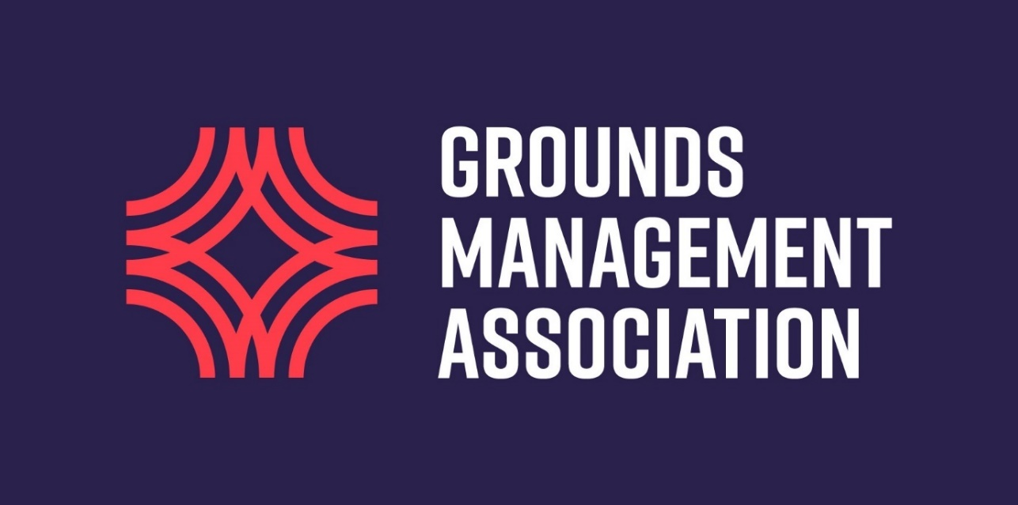

Grounds Teams

- Level 1 Cricket Grounds Maintenance - Online
This online option will suit those volunteers that do not have time to travel and attend a course. You will learn about that tasks involved in maintaining a playing surface in a cost-effective way.
Member Price - £52.00 (Incl. VAT)
Non Member Price - £74.00 (Incl. VAT)

There are 3 modules to this training course. All are designed to either give you a new understanding or build on your experiences so far.
- Requirements of the groundsperson and pitch
- Maintenance activities (Equipment and Machinery)
- Safe use and storage (Materials)
For more information and to book click here Level-1 Cricket Grounds Maintenance

- Level 2 Cricket Surfaces (applied turf culture)
This online course will allow you to understand how technical aspects of turf maintenance can influence overall pitch quality, helping to create a suitable annual maintenance plan for your playing surface.
Member Price - £104.00 (Incl. VAT)
Non Member Price - £149.00 (Incl. VAT)
By the end of this course, you should be able to understand:
- The performance requirements of a playing surface;
- How to monitor the quality of a surface;
- How different maintenance activities might influence pitch playability;
- The responsibilities of operatives and organisations;
- The purpose of risk assessments;
- Different soil types;
- Basic drainage design;
- How to identify turf grasses in general;
- General control methods for undesirable organisms;
- The use of annual work schedules; and
- How to create an annual work schedule.
We suggest the course takes 4-6 hours to complete, however, you can complete the course at your own pace and save your progress as you go.
For more information and to book click here Level-2 Cricket Surfaces

