
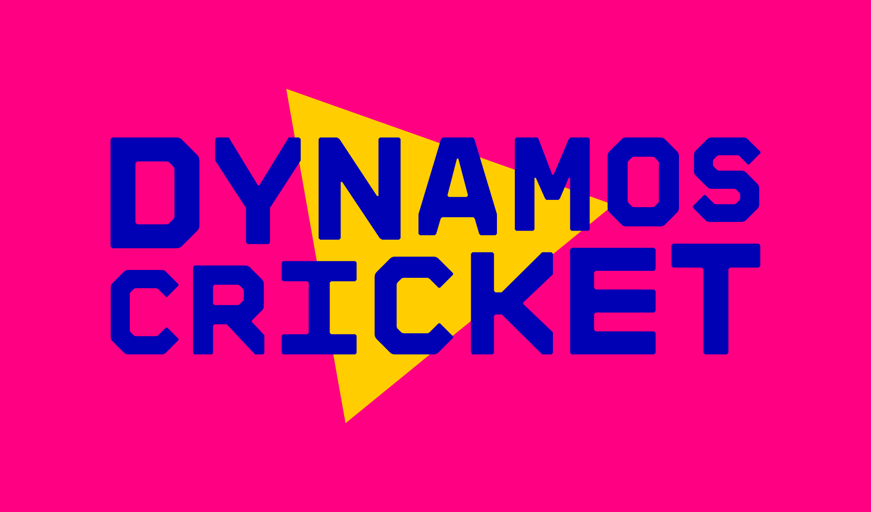
National Primary Schools
Dynamos Cricket Festivals 2025
Name of School
Headteacher
Sports Coordinator
School Post code |  | School number
Mobile number (1) |  | Mobile number (2)
School email
Additional email

Girls Only Dynamos Cricket Festivals
Date | Venue | Arrive | No of teams | Attendance  * mark as appropriate
Monday 9th June | Herefordshire Cricket Centre | 9.15am |  | YES* / NO *
Tuesday 10th June | Herefordshire Cricket Centre | 9.15am |  | YES* / NO *
County Finals Tuesday 24th June at Herefordshire Cricket Centre

Years 3 and 4 Mixed Festivals
Date | Venue | Arrive | No of teams | Attendance  * mark as appropriate
Thursday 12th June | Herefordshire Cricket Centre | 9.15am |  | YES* / NO *
Friday 13th June | Herefordshire Cricket Centre | 9.15am |  | YES* / NO *
County Finals Tuesday 24th June at Herefordshire Cricket Centre

Years 5 and 6 Mixed Festivals

Date | Venue | AM | No of teams | Attendance  * mark as appropriate
Monday 16th June | Wormelow | 9.15am |  | YES* / NO *
Tuesday 17th June | Dales CC | 9.15am |  | YES* / NO *
Thursday 19th June | Herefordshire Cricket Centre | 9.15am |  | YES* / NO *
Friday 20th June | Herefordshire Cricket Centre | 9.15am |  | YES* / NO *
County Finals Thursday 26th June at Herefordshire Cricket Centre

Please return the completed form to the following email address: kirstysockett@herefordshirecricketltd.co.uk

