Herefordshire Cricket Limited

FACILITIES DEVELOPMENT PLAN 2023+
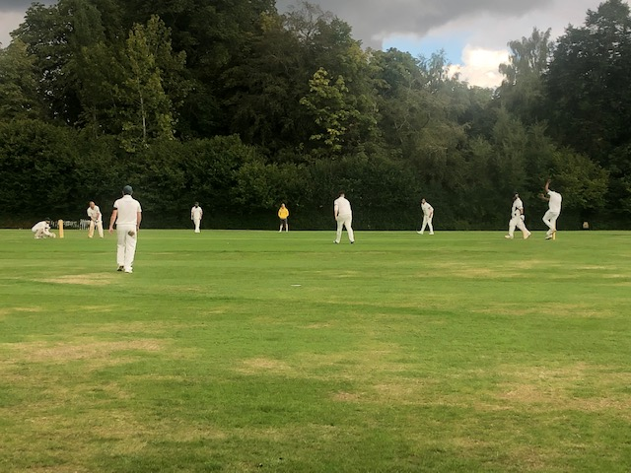

Executive Summary

Over the next 10 years, we now have clearly defined targets that will service the future of the game locally across Herefordshire. This will underpin our County Partnership Agreement with the England & Wales Cricket Board, our County Wide Plan, and provide a foundation for the development and growth of the game.
Herefordshire Cricket will:

- Support Traditional Clubs

- Indoor Training provision which is fit for purpose.

- Ensure female participation is prioritised

- Develop facility partnerships with schools which benefit clubs and pupils.

- Develop key sites for performance cricket.

- Work with all clubs and facility providers to improve access for disabled users

- Work with ECB and other key partners to prioritise the game’s response to climate change.

- Support Traditional Clubs

- There is currently sufficient capacity of natural turf cricket squares to meet current demand for club cricket at an Authority wide level. However, this is not always in the locations where it is required. See section 4. ‘Develop facility partnerships with schools which benefit clubs and pupils’ for further details on plans to support these areas.

There are four disused sites which formerly had cricket pitch provision, at The Hayes, Sapey Cricket ground, Pencombe Recreation ground and Marden Recreation Ground which HCL need to consider carefully as to the future potential possibilities for usage in conjunction with interested partners eg Council, Clubs, Other stakeholders. These decisions will have significant impact on Section 4 of the report. Eg Schools Partnerships, Friendly Cricket etc or a combination plan.
All but four clubs in Herefordshire have secure tenure at their home venues through ownership, long term lease and formal rent agreement.
We will engage with each of the four clubs to fully understand their situations and, where required, offer support to increase security of tenure.

- Of the 26 squares available for community use, 17 are rated as good quality (65%) and nine are rated as standard quality (35%).
We will create improvement plans with each of the nine rated as standard. This work will include, but not be limited to -
- Education (for staff/ volunteers)
- Support from Pitch Advisors
- Machinery

- The audit of ancillary facilities at available grass pitch cricket sites determines that nine squares (35%) are accompanied by good quality provision, whilst 11 (42%) squares are accompanied by standard quality provision. There are three (12%) squares accompanied by poor quality provision.
We will work with clubs/ providers of each facility to create action plans. This will be done in order from ‘poor’ to ‘good’.
Linked to demand, a list of project priorities will then be identified.

- Indoor Training provision which is fit for purpose.

In 2021 -2023 Knight, Kavanagh & Page Ltd (KKP) was appointed by Herefordshire Council ‘to produce a Built Indoor Sports Facilities Strategy (BFS) 2021-2041'. This work provides a key piece of evidence to support the update of the Herefordshire Local Indoor Cricket Plan Strategy.
The audit was conducted between December 2021 and February 2022. Where access to sites was not available KKP carried out non-technical quality assessments via desktop research, and where possible quality was accessed via utilising virtual ‘walk arounds’ of the health and fitness suites or videos and photos present on the operator’s website or in discussion with the operator.
It is a concise, robust, comprehensive, and up-to-date evidence base in line with the emerging Local Plan. It sets out a strategic, action plan-based approach to the enhancement of existing, and creation of new, sporting provision. This will ensure that residents have the opportunity to be physically active and healthier, and where appropriate develop their physical, sporting, health and wellbeing ambitions within their local cricket community.
- HCL will review, refine, and implement action plan.

- Ensure female participation is prioritised

Herefordshire CL reports that in the coming 2-3 years it is looking to grow women’s and girls’ cricket within Herefordshire. There are currently three women’s and girls’ teams at present in Herefordshire (two women’s teams at Brockhampton CC and Colwall CC, one junior girls team at Ross-on-Wye CC). Herefordshire CL has started to work on improving this with two further women’s and girls’ programme in the Authority at Bartestree & Lugwardine CC and Wormelow CC. Further clubs have expressed interest in this in the Winter/Spring of 2023. 6 in all. Target is 9 Ws and Gs sections by the end of 2023.
- Support each identified W&Gs hub to consider improvements required to current facilities with a focus on being ‘female friendly’.
- Link this to ‘traditional clubs’ section, prioritising investment in those clubs that seek to embrace W&Gs cricket.

- Develop facility partnerships with schools which benefit clubs and pupils.

There are many examples nationally of clubs forging mutually beneficial facility partnerships with schools to share outdoor facilities. Schools have the space, and sometimes existing squares, but often lack the expertise required to maintain and improve the fine turf provision. Conversely, clubs often struggle for the required green space but have the expertise regarding maintain and improving fine turf provision.

In Herefordshire, unmet demand lies with Bartestree and Lugwardine & Burghill Tillington and Weobley, who both require facilities for their 3rd XI League Cricket on a Saturday.

Table : Sites with actual spare capacity to accommodate senior Saturday cricket
Analysis area | Site ID | Site
Golden Valley | 35 | Coppice Field (Moccas Cricket Club)
Ledbury | 33 | Colwall Cricket Club
Ross-on-Wye | 136 | The Avenue (Goodrich Cricket Club)
Table : Summary of overplay.
Analysis area | Site name | Site ID | Number of squares | Overplay  (Matches per season)
Senior wickets
Hereford | Burghill Tillington & Weobley Cricket Club | 25 | 1 | 12
Ross-on-Wye | The Parks | 147 | 1 | 11
Total |  |  | 2 | 23
Junior wickets
Bromyard | Flaggoners Green | 206 | 1 | 3
Ledbury | Colwall Cricket Club | 33 | 1 | 4
Total |  |  | 2 | 7

- HCL to identify schools local to the clubs listed and identify current fine turf provision at these schools.
- HCL to engage with clubs to explore what could be offered to the local school by HCL and the relevant club/s.
- HCL to support clubs to engage in initial discussions with suitable schools.

- Develop key sites for performance cricket.

Currently the priority grounds for Performance and NCCA Cricket in alphabetical order are Brockhampton CC, Colwayy CC and Eastnor CC along with Pentand Gardens (HCL Cricket Centre) Wormelow, Luctonians with others in currently in discussions (2023-2024)

I would imagine you have grounds you currently use regularly for performance cricket. I would develop a simple model for what a ‘performance ground’ needs to have and map this against existing provision. This will produce ‘gaps’ for you to fill through partnership working and funding.

- Work with all clubs and facility providers to improve access for disabled users

The Disability Discrimination Act 1995 places a duty on employers and service providers to prevent discrimination against people on the grounds of their disability. This includes a requirement to make reasonable adjustments to policies, practices and procedures and to remove physical barriers to accessing services.
Sport England believes that good facilities are fundamental to developing sporting opportunities for everyone, from the youngest beginner to the international class athlete. The buildings whether large or small can encourage civic pride and assist the process of revitalising deprived neighbourhoods. Facilities that are well designed built to last and well maintained are a pleasure to use and give an ample return on the time and money invested in their construction and day to day use. Good design needs to be based on a sound understanding of such issues as the current trends and practices within individual sports, developments in the sport and leisure industry and the lessons to be learnt from previously built schemes. Good design needs to be embraced within the earliest vision statement for a particular project and enshrined in the initial briefing stage through to the final detailed specifications and operational arrangements.
More details, including a series of guides and checklists, are all available via the Sport England website - Accessible facilities | Sport England
- HCL to review Sport England documents and produce a communications plan for clubs.
- HCL to ask each club to rate accessibility of their facilities – both playing and non-playing via short survey every 3 years.
- HCL to review survey and produce action plan to address challenges via Club Visits, Groundcare Courses and Grant Aid support.

6 Work with ECB and other key partners to prioritise the game’s response to climate change.

Climate Change and the affect it has on local cricket in Herefordshire is a vital for the game to understand and begin to address. The impact of climate change will only increase across the lifespan of this strategy, and we must act now to ensure our facilities are ready for this challenge.
Fully understanding the challenges posed by climate change and the impact this will have on the game is a task we will work in partnership with the England & Wales Cricket Board on. The ECB are currently (August, 2023) developing a Sustainability Plan for the game and we look forward to learning more about how we can future-proof the game in the medium to long-term.
In the short-term, we will focus on taking positive action to help address flooding, drought, and energy consumption.
We know that 40% of clubs in England & Wales are already at risk of flooding or drought and we are seeing those maintaining our grounds having to deal with increasingly extreme and unpredictable weather events. In addition, increased energy consumption and the associated costs not only impact the planet but also the finances of clubs.
Below you will find links to the ECB’s latest guidance, developed in partnership with other key organisation such as the Grounds Management Association, on each of these three areas -
Flooding
https://www.ecb.co.uk/be-involved/club-support/club-facility-management/flooding
Drought Assessment
https://www.ecb.co.uk/be-involved/club-support/club-facility-management/drought-assessment
Energy Saving
https://www.ecb.co.uk/about/what-we-do/sustainability

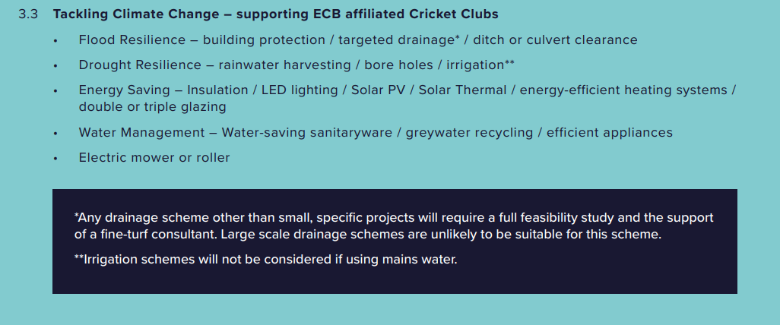
Funding support is currently available for clubs through the County Grants Fund. Below you will find further details regarding this funding, and the project themes linked. County Grants Fund documents can be found in full as an appendix to this strategy.

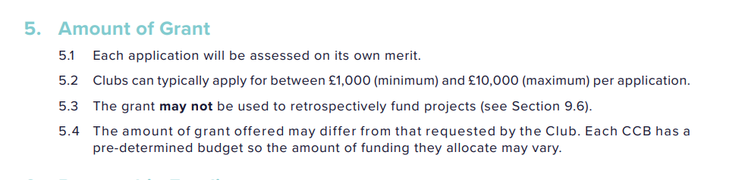

- HCL will support clubs to access funding and other resources to follow the same themes as the County Grants Scheme, shown below.This support will take the form of a multi-faceted sustainability campaign, launched annually in advance of the County Grants Fund. The campaign will seek to –
- Highlight the challenges posed by climate change.
- Share examples of best practice in dealing with these challenges.
- Provide advice to clubs regarding sources of funding for sustainability projects.
- We will identify and work closely with specific clubs which have faced acute challenges linked to climate change.
CONCLUSION
The development of this strategy, which has included gathering important information about where we are and extensive consultation with key stakeholders, has provided the organisation with the best understanding of current provision we have ever had.
A part of this process, we have considered at length how the world around us is changing, including population growth, demographics, climate change, and lifestyle changes, and the impact this will have on the facilities required.
Whilst this strategy covers a 10-year period, the investments made will impact the development and accessibility of the game well beyond this period. This highlights the importance of the work we have done, the conclusions we have drawn, and the need to ensure this strategy continues to evolve over its lifetime.

